Mandate & Payment Screen Layouts Changes and Validation

Changes Required

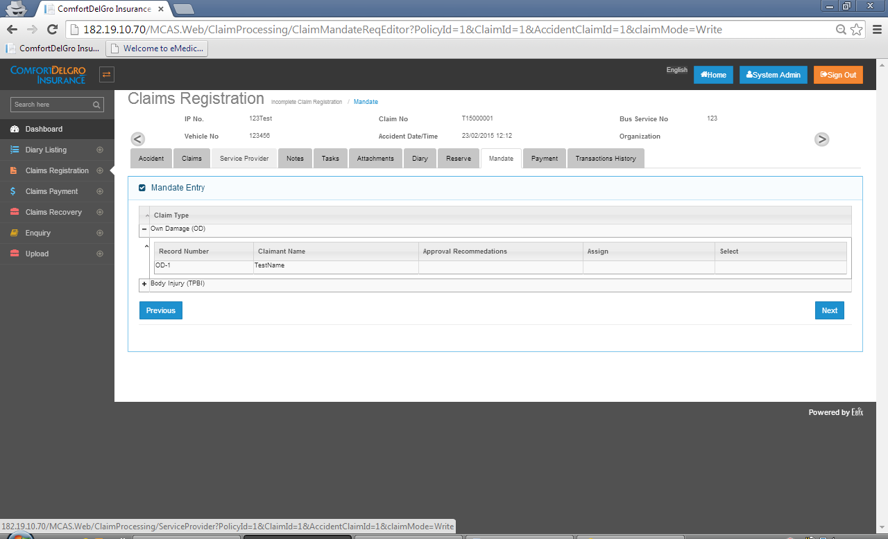

1. After Reserve has been created, Claim (OD/PD/BI) will flow to the Mandate Screen for User to create Mandate Request and System needs to allow user to add Individual / Multiple Mandates.

* Need to have +/- for each Record Claim Number Generated and under Select Column, we need to have an Add Mandate Button as well as a View/Edit Mandate Button
* Clicking on the Add Mandate Button, System will show the relevant Mandate Screens for the Claim Type.
* View Mandate Button is for Mandate Requests that have been sent to Supervisor for Approvals
* Edit Mandate Button is for Mandate Requests that have not been sent to Supervisor for Approvals. User can go in here to edit the values and fields.

1. After Mandate has been requested and approved, it will flow to the Payment Tab and user is allowed to create multiple Payment Requests for a Single Mandate.

* Creation Of Payment Request Layout is similar to the proposed changes for Mandate.

1. Multiple Partial Payment Requests are allowed for all fields as long as it is within the Approved Mandate Amount. Likewise for LOG Medical Expenses.
2. Once first Payment is approved, System will deduct the Initial Approved Mandate Amount. Subsequent Payment that can be approved will depend on the outstanding Approved Mandate Amount.

Validation Required

1. For Payment to be approved by Supervisor, System needs to check:

* Supervisor is within the Financial Authority Limit to approve the Amount
* Payment Amount is below or equal to the Current Reserve and Current Approved Mandate. System will use the lowest amount for approval.
* Note that there may be other Payment Approvals going on at the same time for other Mandates so System needs to take note of the latest Current Reserve Amount to validate.

1. As long as Mandate Requests and Payment Requests have not been submitted to Supervisors for Approval (which means that they are saved), user can edit the fields. Once Requests have been submitted to Supervisors for approvals, system does not allow